Section 5

SPECIMEN EXAM QUESTIONS
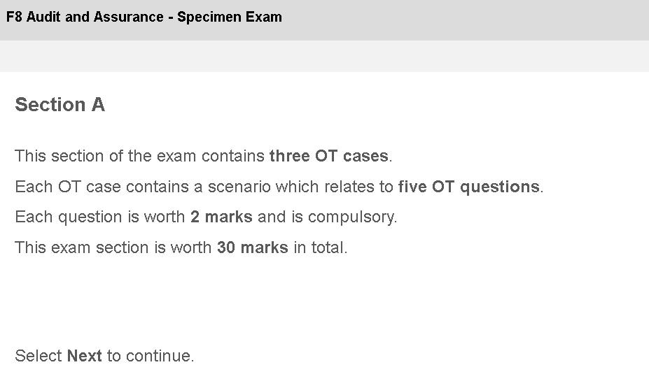

KAPLAN PUBLISHING 403

AA: AUDIT AND ASSURANCE
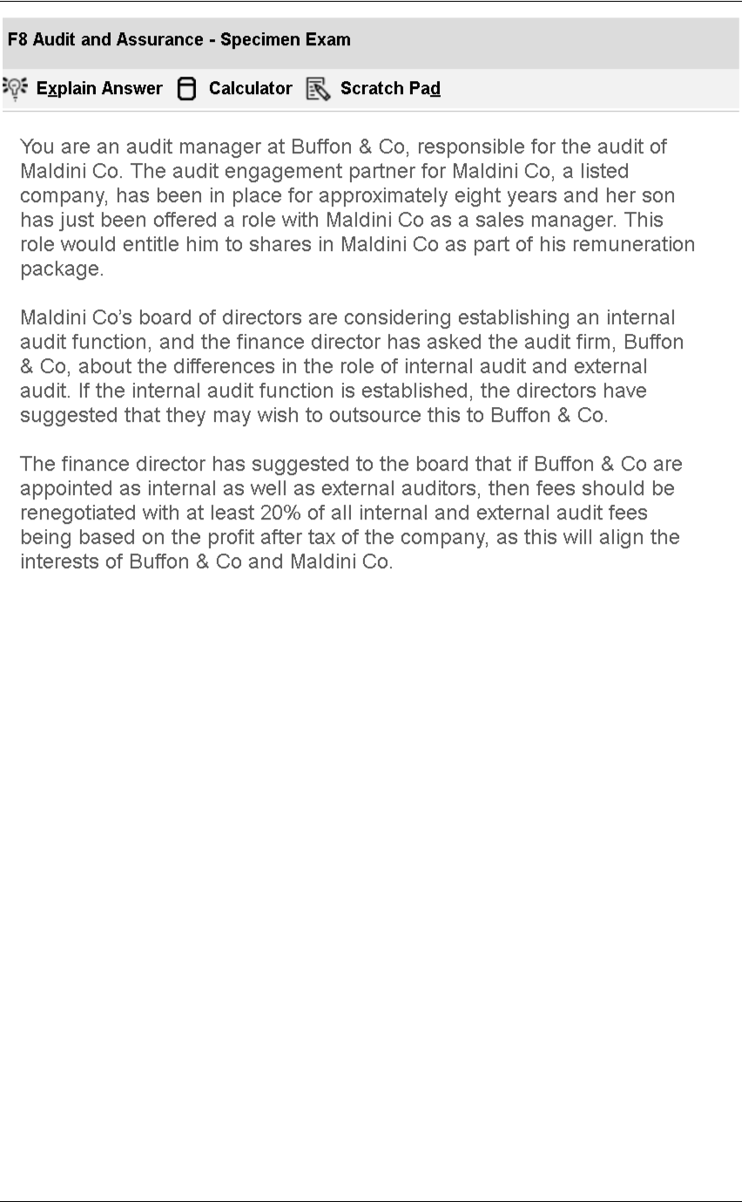

404 KAPLAN PUBLISHING

SPECIMEN EXAM QUESTIONS : SECTION 5

Q1
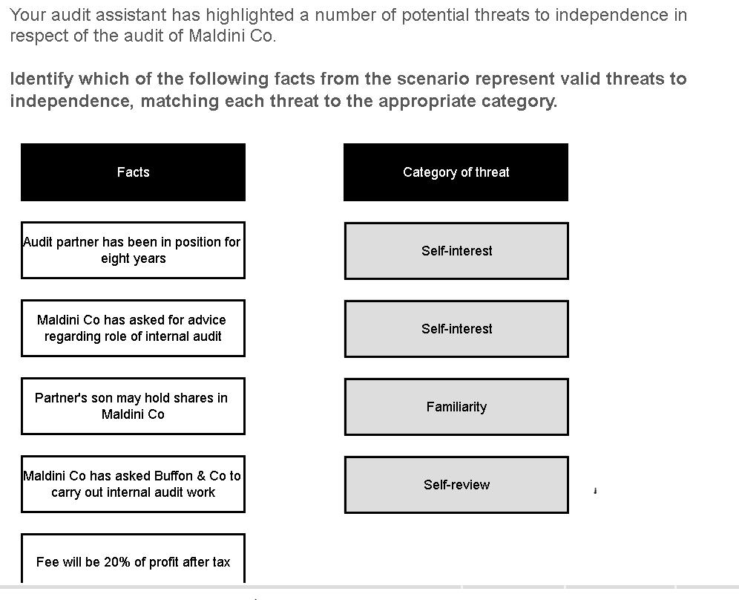

Q2
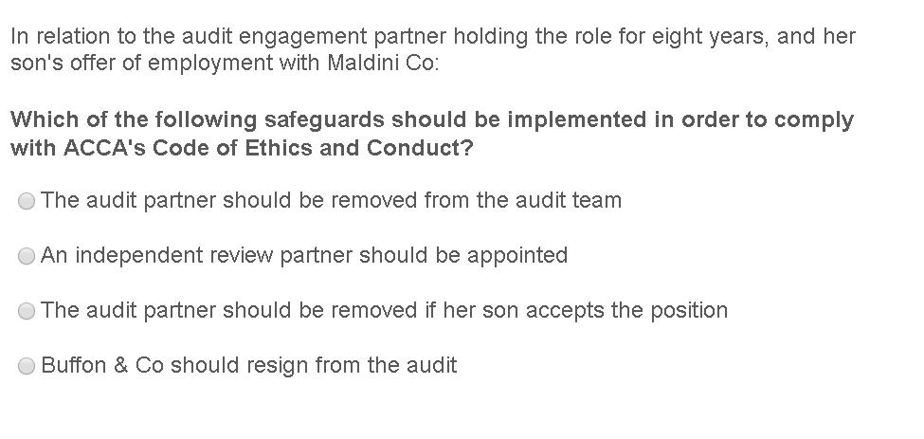

KAPLAN PUBLISHING 405

AA: AUDIT AND ASSURANCE

Q3
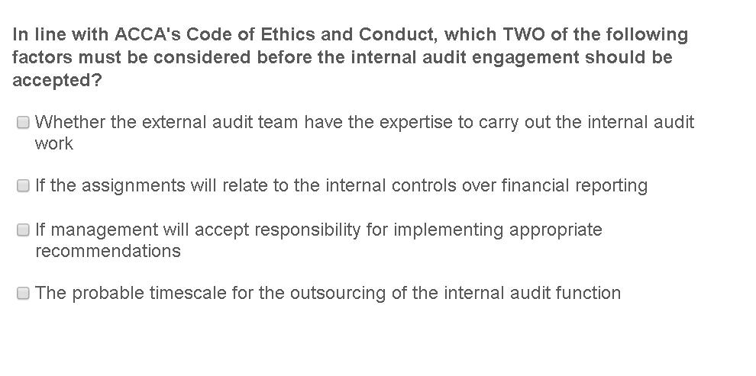

Q4
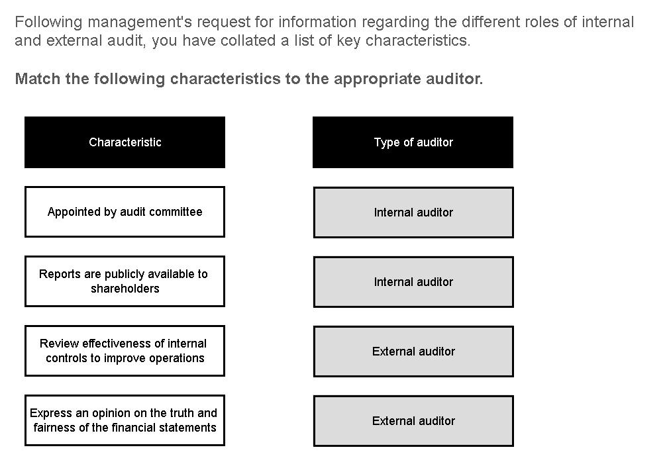

406 KAPLAN PUBLISHING

SPECIMEN EXAM QUESTIONS : SECTION 5

Q5
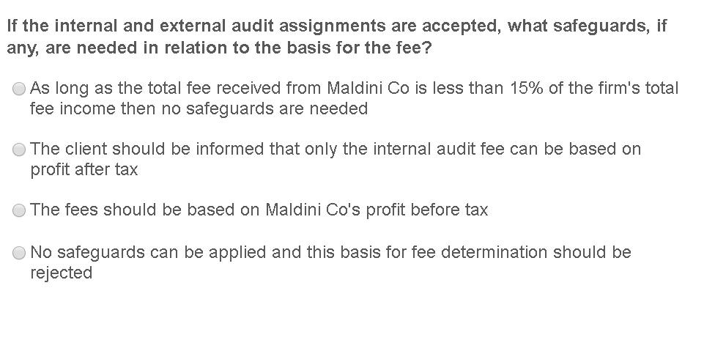

KAPLAN PUBLISHING 407

AA: AUDIT AND ASSURANCE
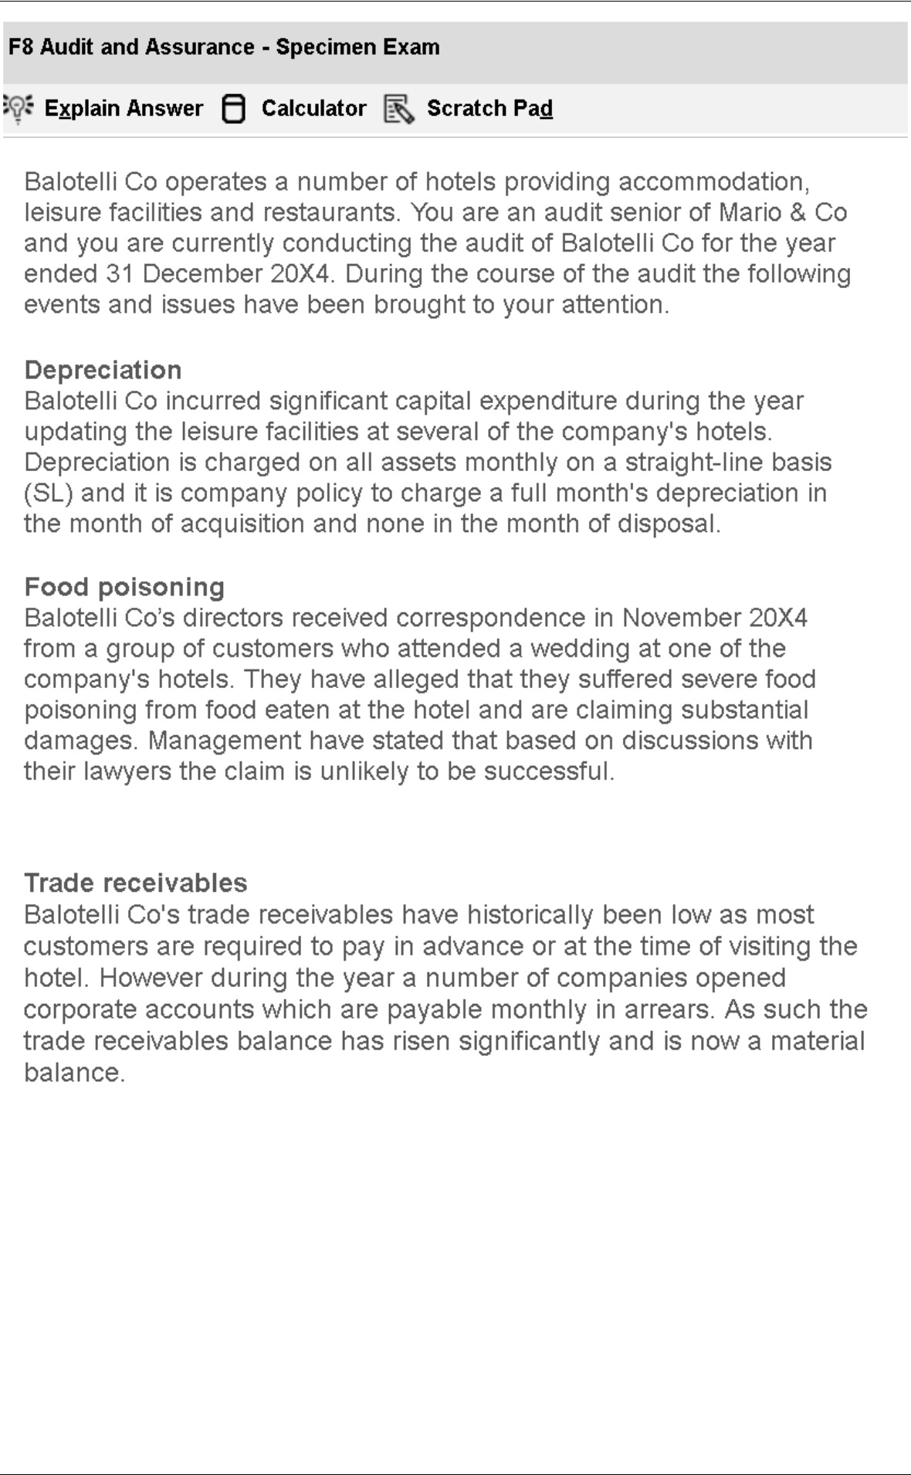

408 KAPLAN PUBLISHING

SPECIMEN EXAM QUESTIONS : SECTION 5

Q6
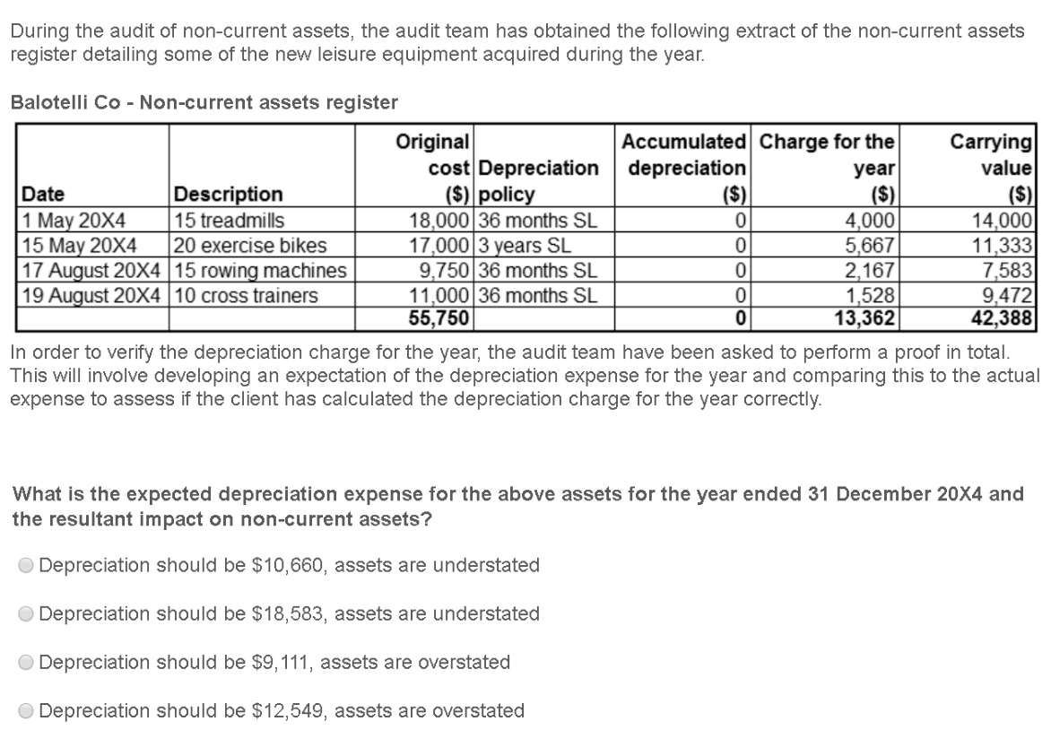

KAPLAN PUBLISHING 409

AA: AUDIT AND ASSURANCE

Q7
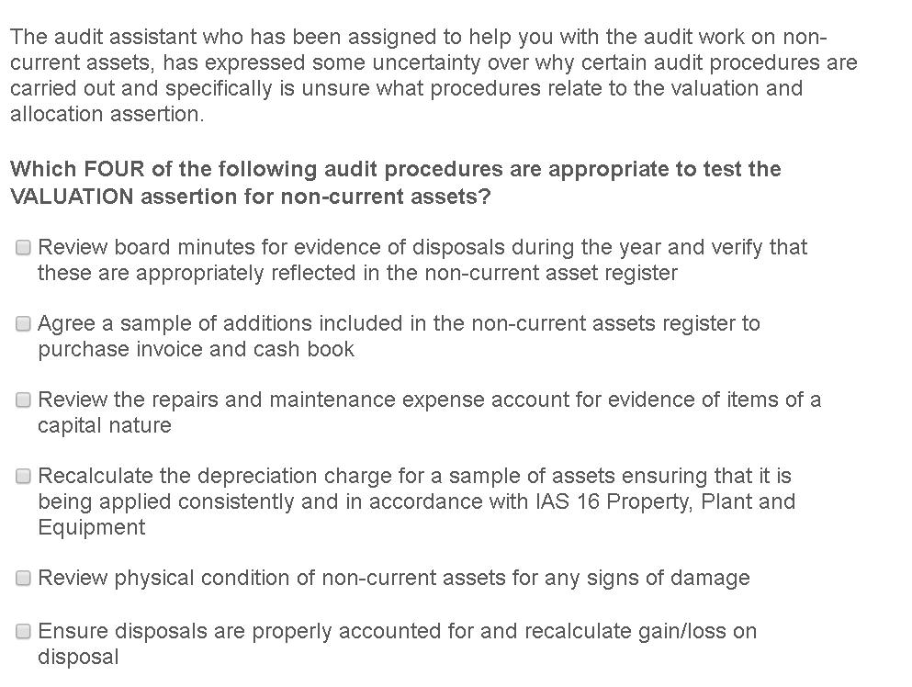

Q8
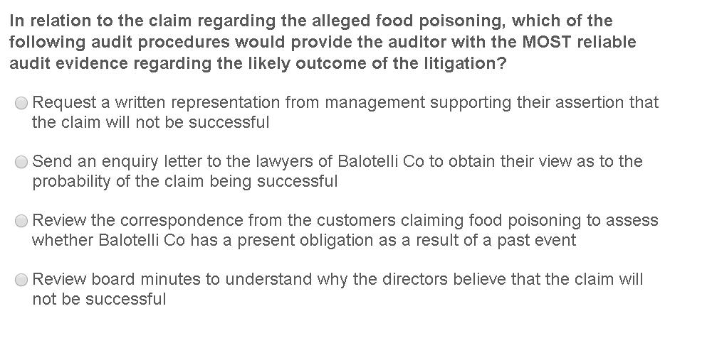

410 KAPLAN PUBLISHING

SPECIMEN EXAM QUESTIONS : SECTION 5

Q9
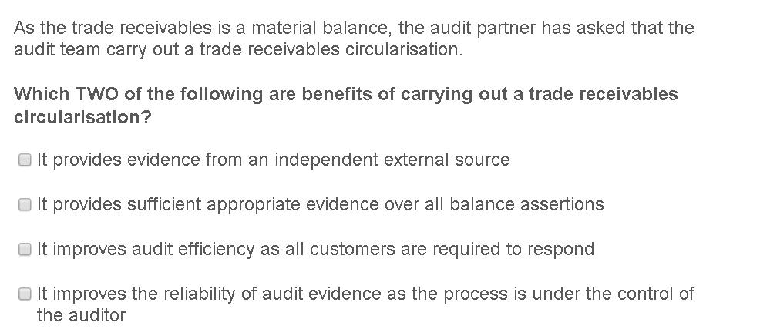

KAPLAN PUBLISHING 411

AA: AUDIT AND ASSURANCE

Q10
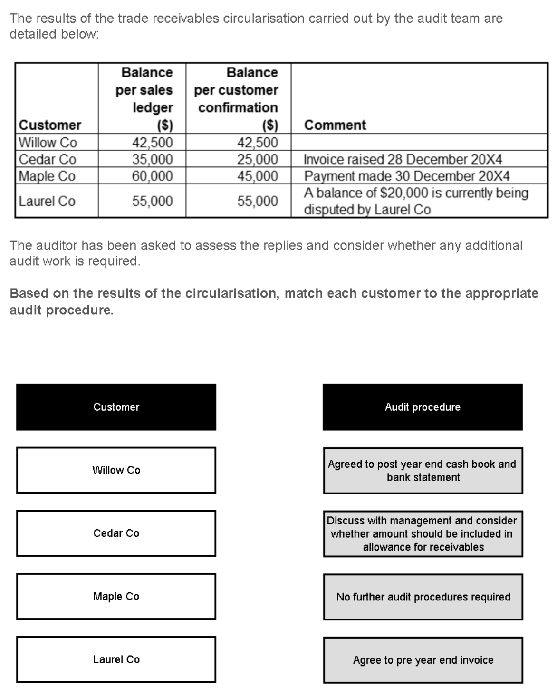

412 KAPLAN PUBLISHING

SPECIMEN EXAM QUESTIONS : SECTION 5
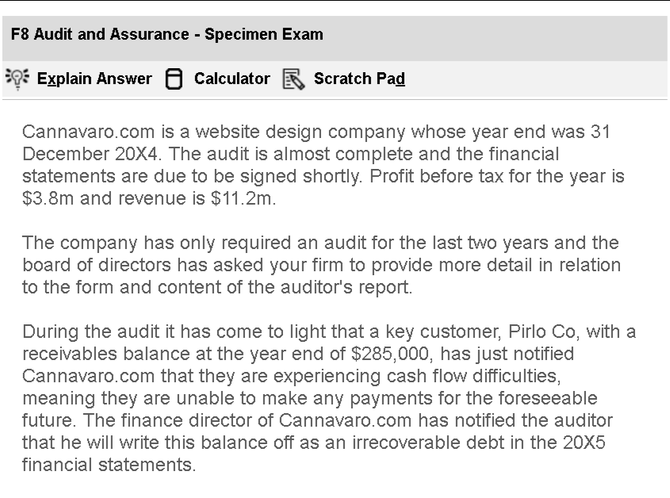

Q11
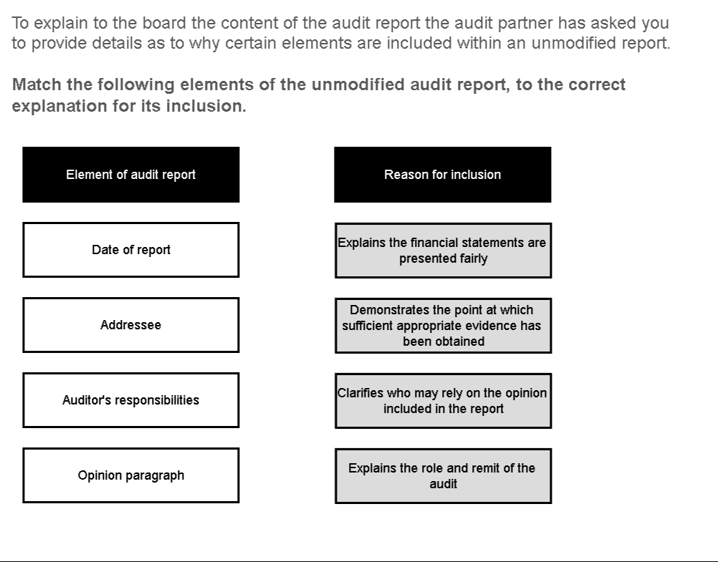

KAPLAN PUBLISHING 413

AA: AUDIT AND ASSURANCE

Q12
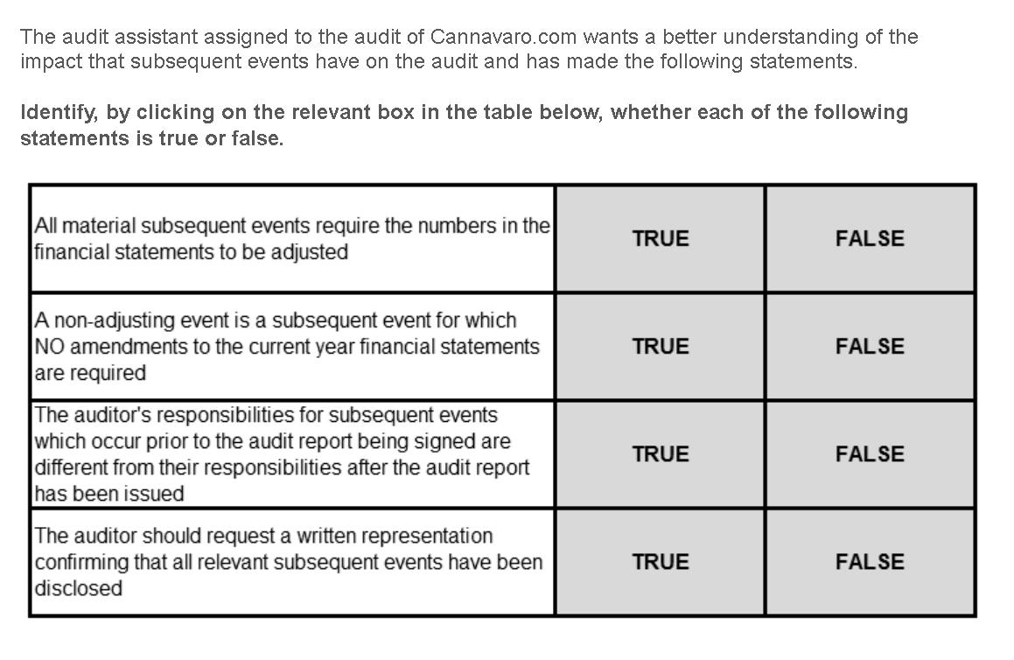

Q13
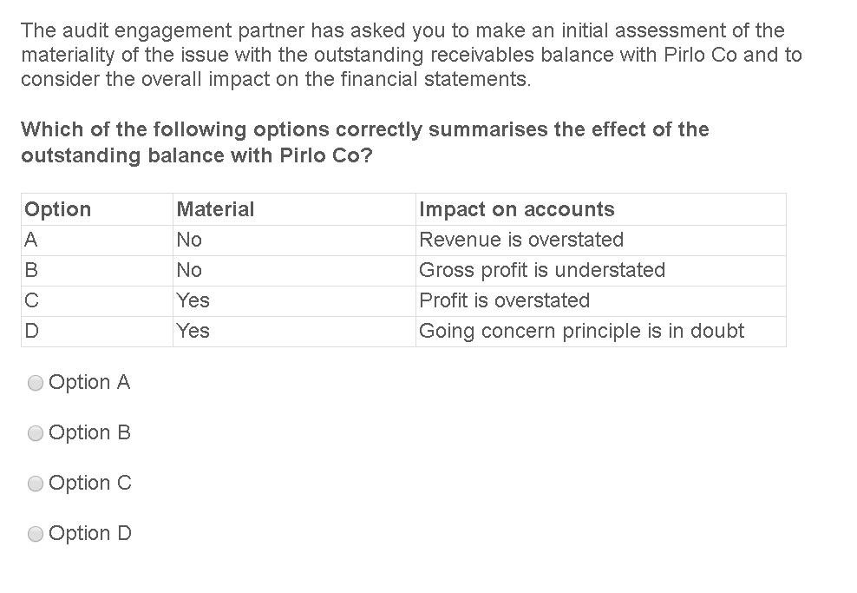

414 KAPLAN PUBLISHING

SPECIMEN EXAM QUESTIONS : SECTION 5

Q14
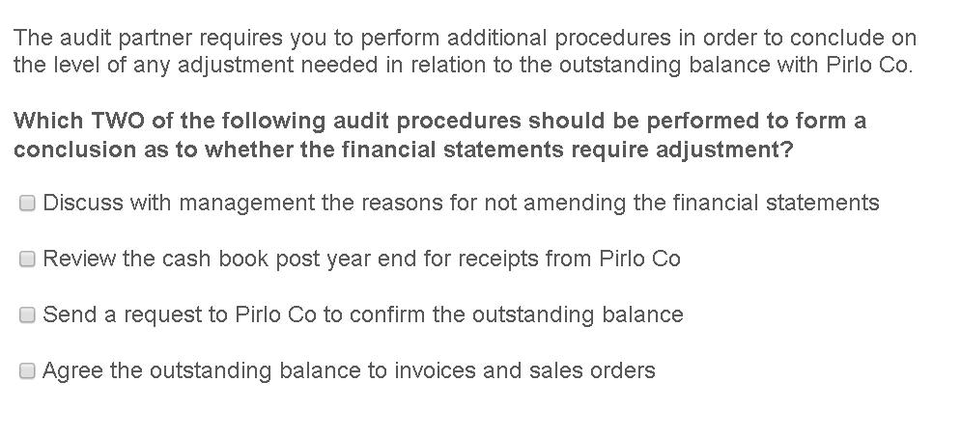

Q15
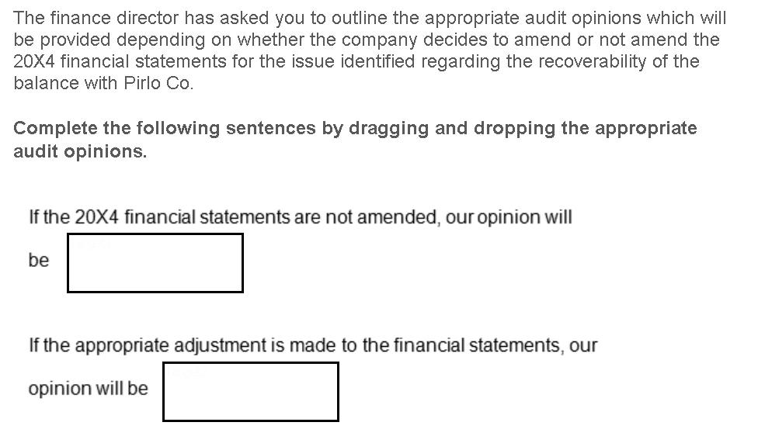
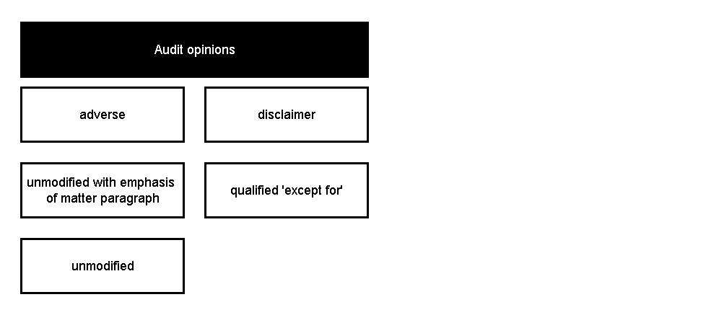

KAPLAN PUBLISHING 415

AA: AUDIT AND ASSURANCE
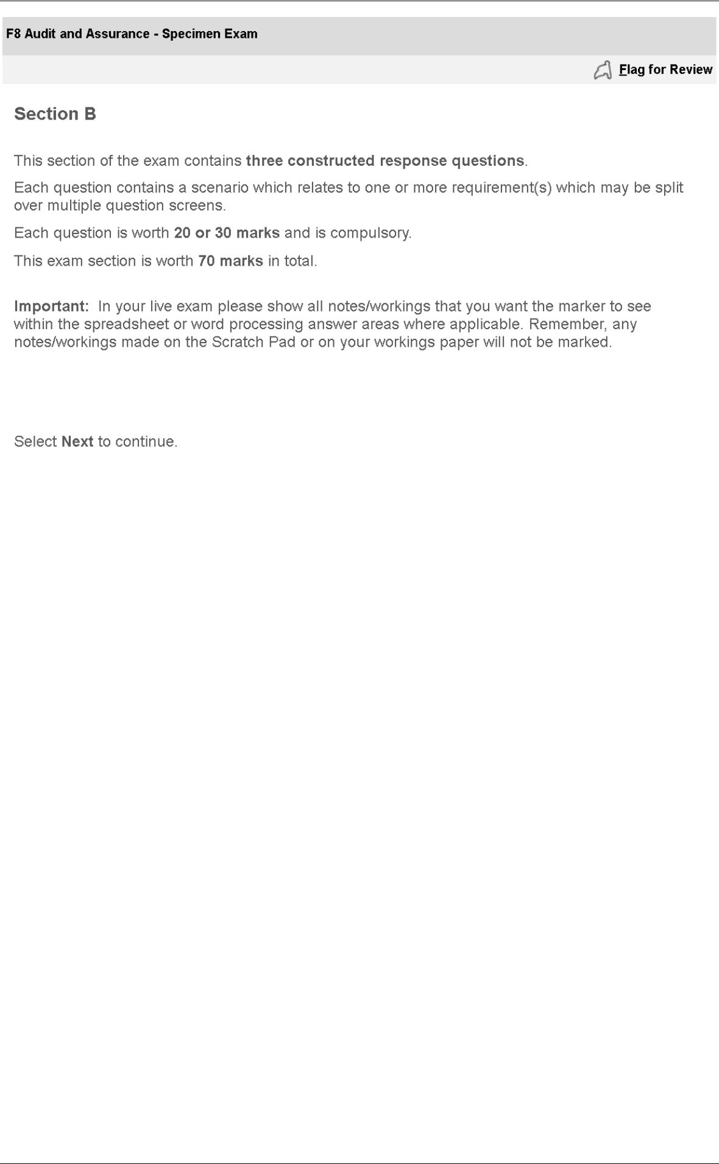

416 KAPLAN PUBLISHING

SPECIMEN EXAM QUESTIONS : SECTION 5
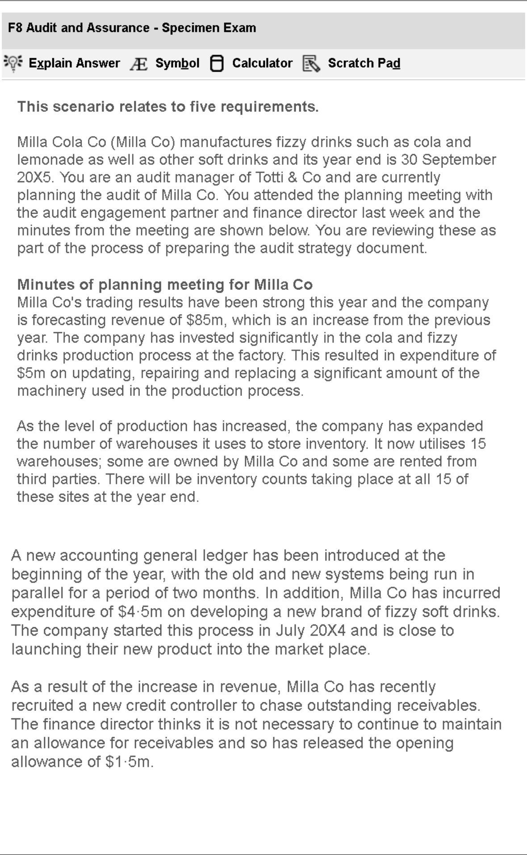

KAPLAN PUBLISHING 417

AA: AUDIT AND ASSURANCE
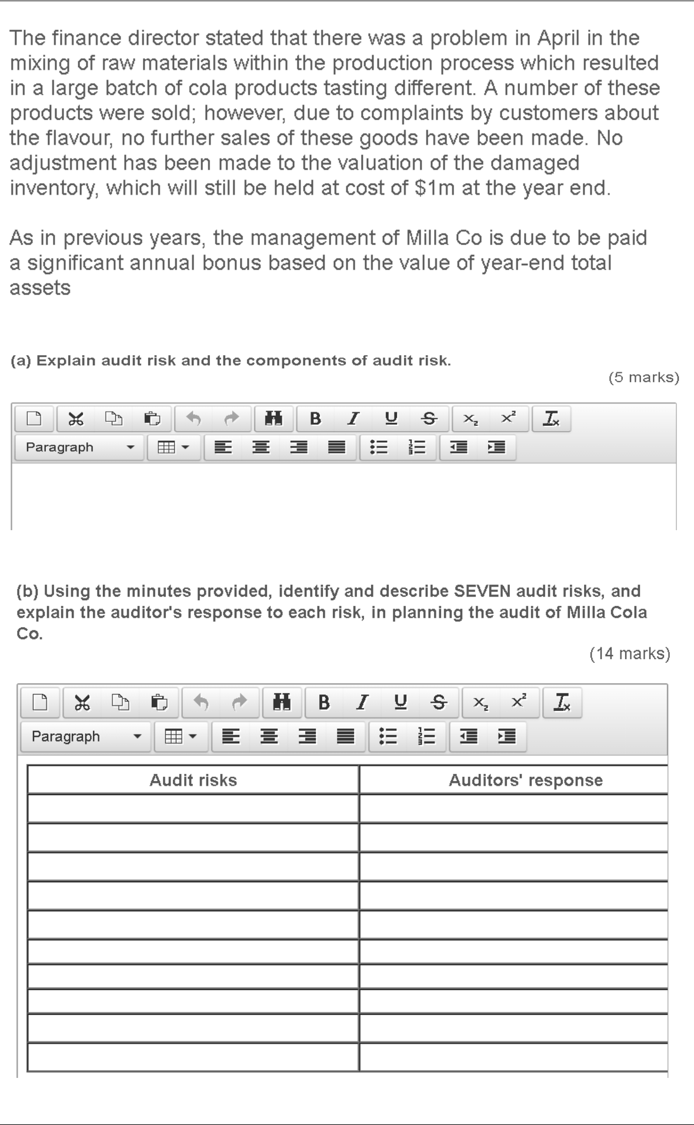

418 KAPLAN PUBLISHING

SPECIMEN EXAM QUESTIONS : SECTION 5
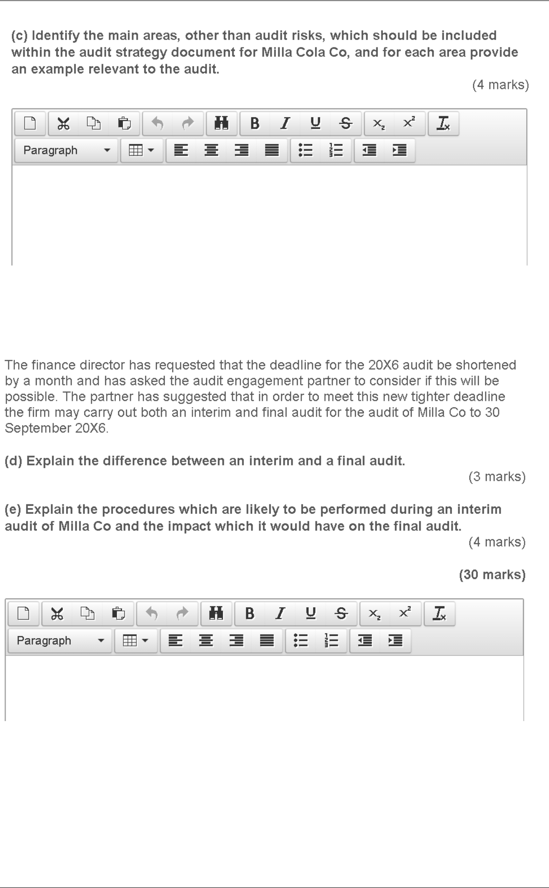

KAPLAN PUBLISHING 419

AA: AUDIT AND ASSURANCE
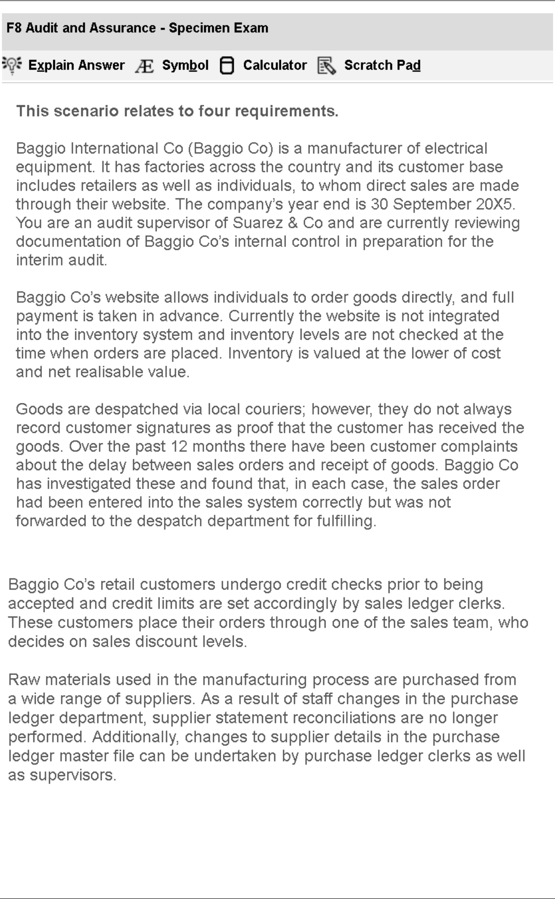

420 KAPLAN PUBLISHING

SPECIMEN EXAM QUESTIONS : SECTION 5
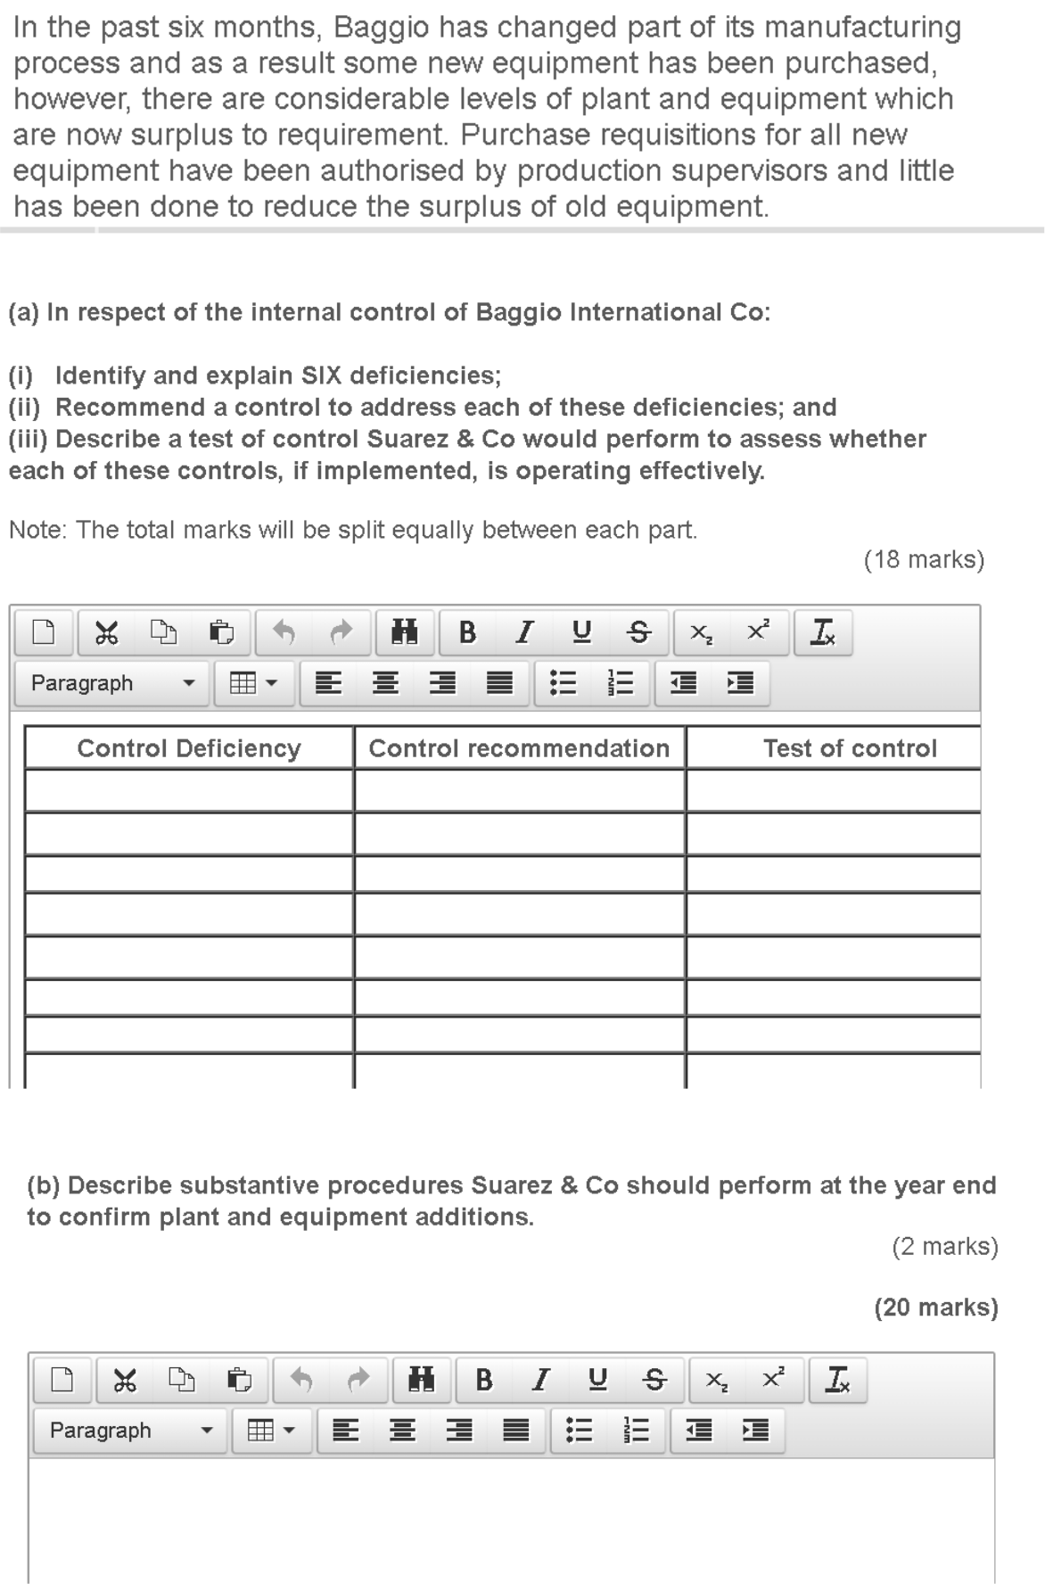

KAPLAN PUBLISHING 421

AA: AUDIT AND ASSURANCE
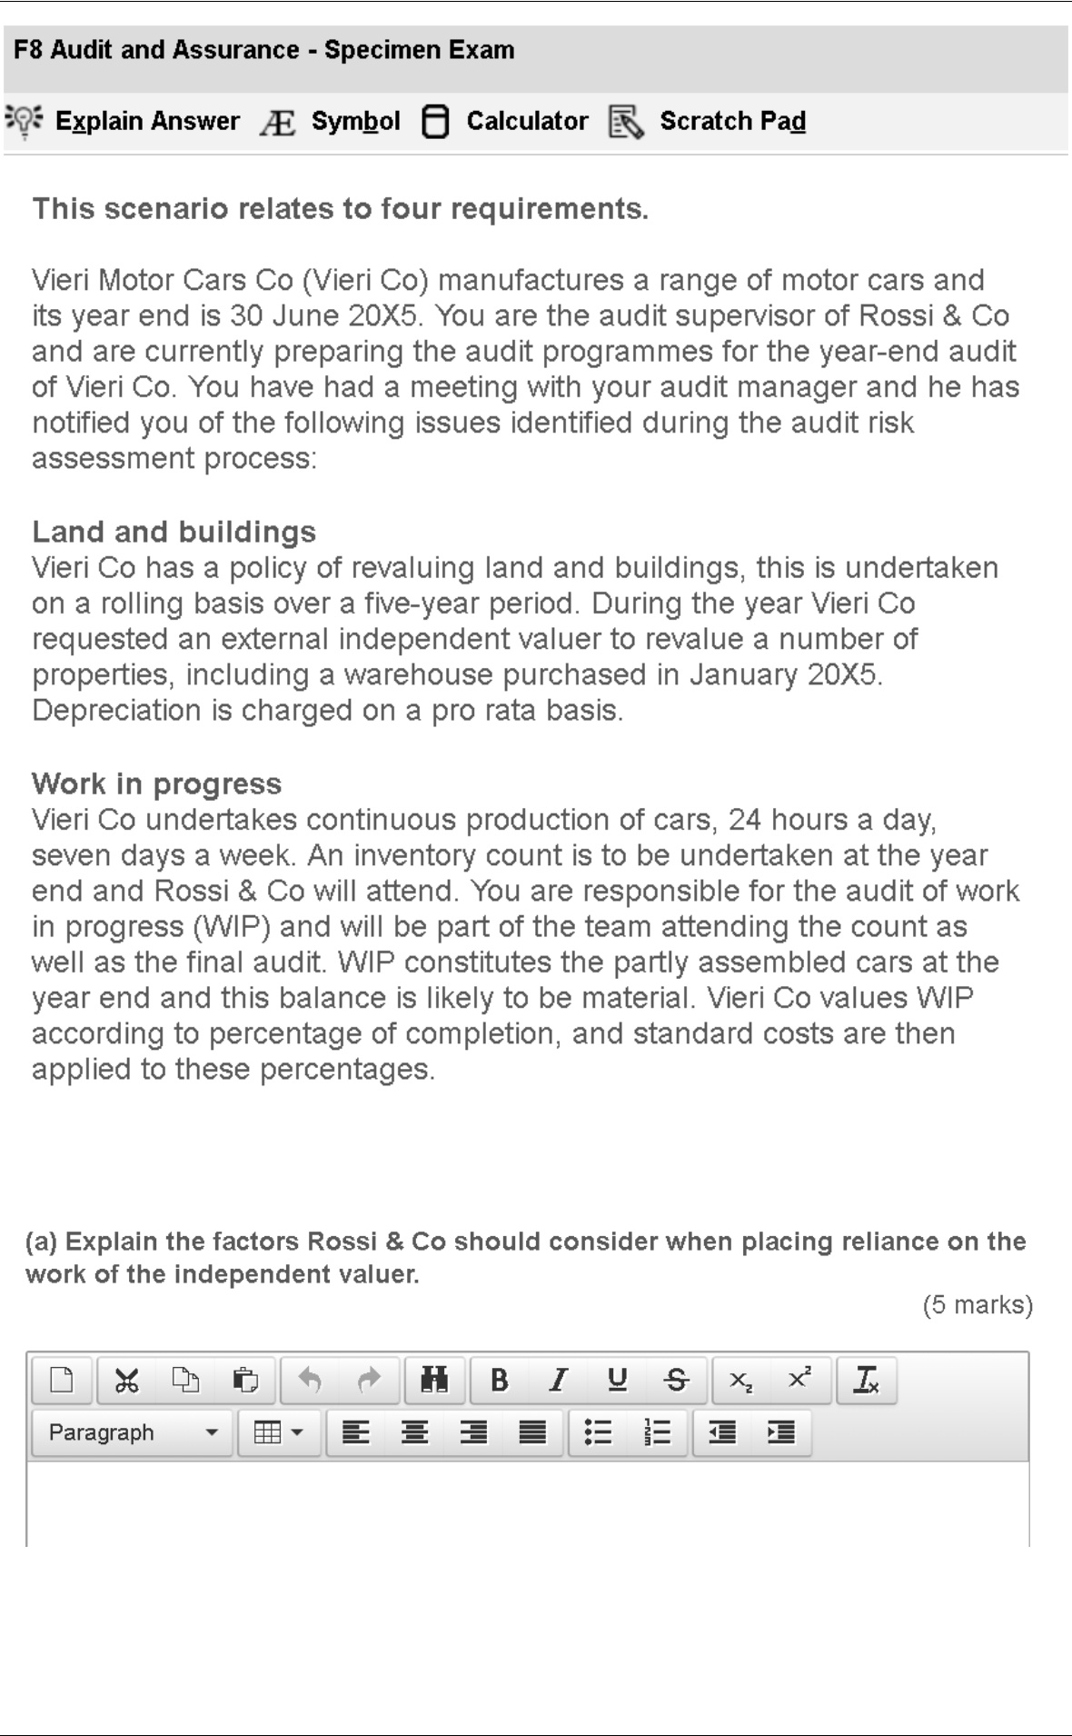

422 KAPLAN PUBLISHING

SPECIMEN EXAM QUESTIONS : SECTION 5
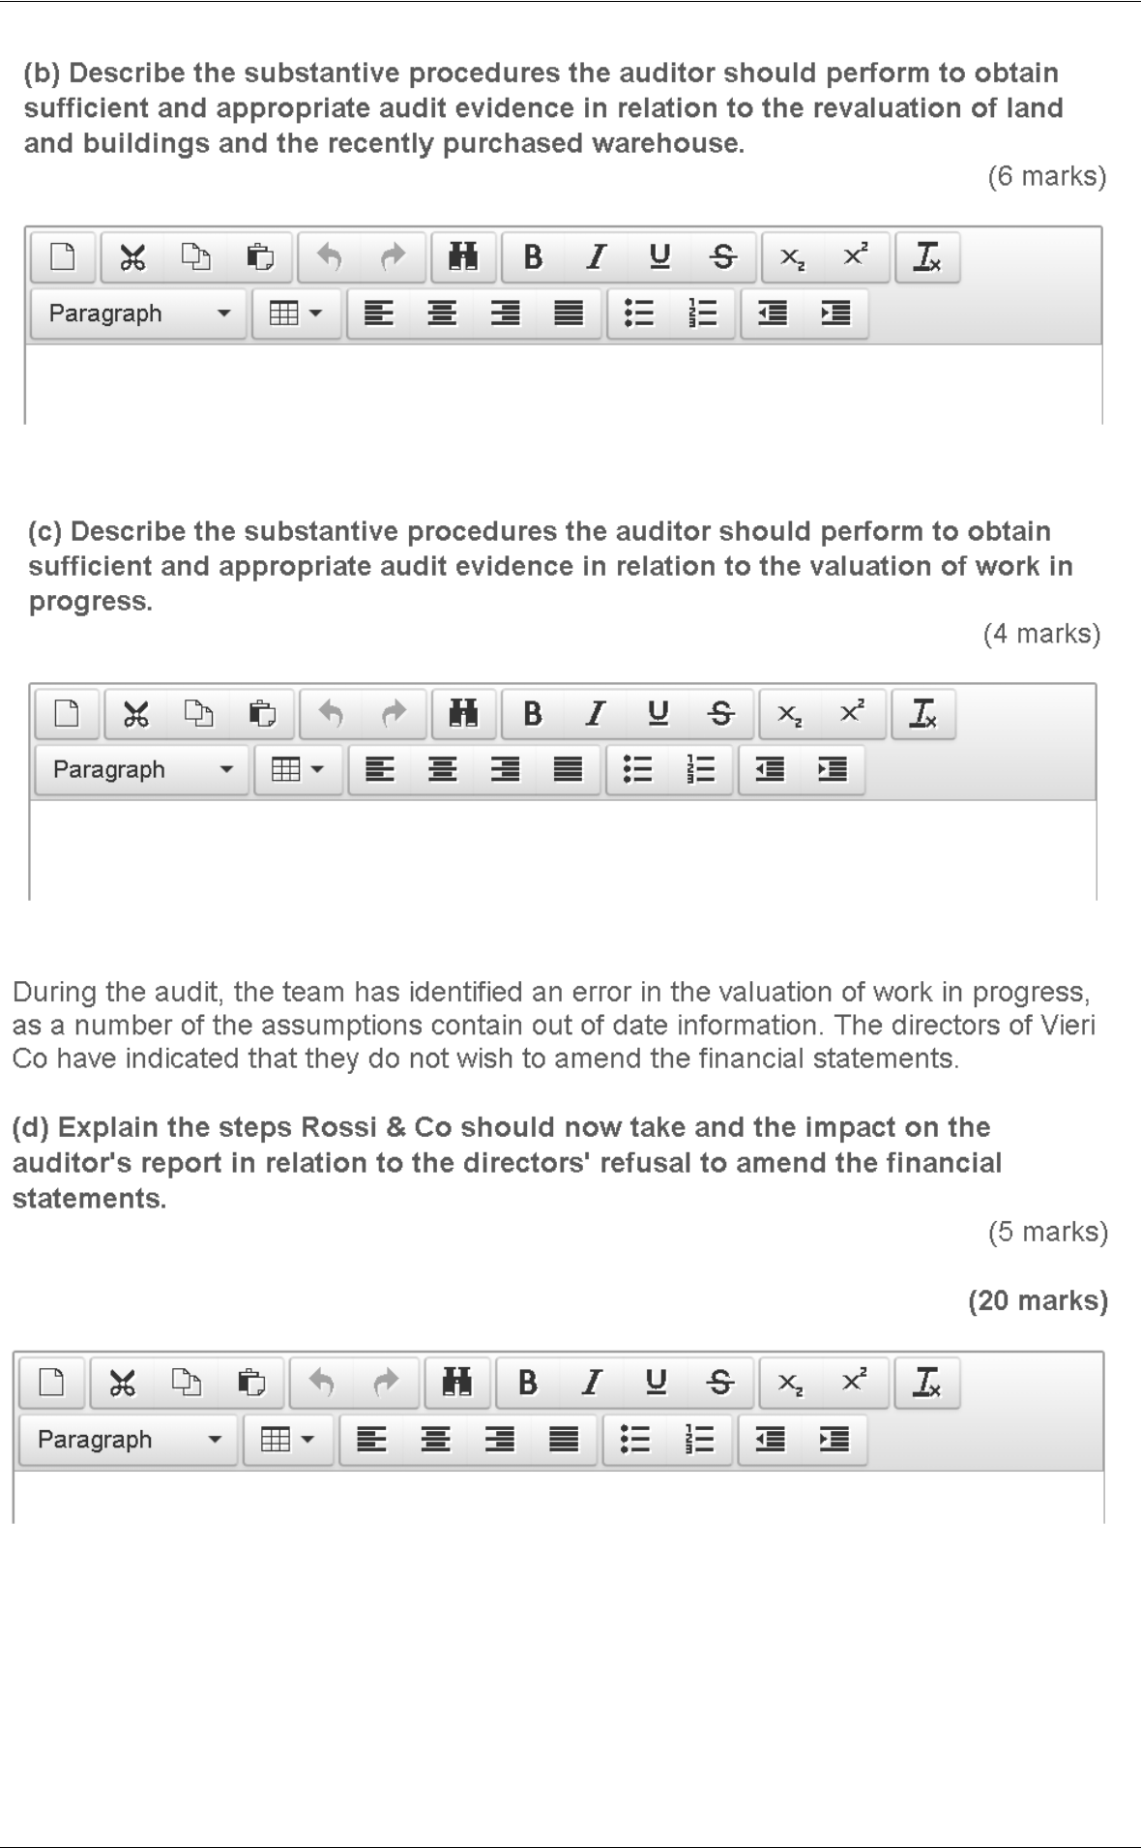

KAPLAN PUBLISHING 423

